**Lab 7P: Files and Exceptions_ 7P_FE**

**Programming Exercises: GADDIS PYTHON 2e Text, Pages 292 – 294**

**Assigned Projects = 3 (65 Pts)**

**Using the IDLE editor (FILE/New Window)……**

**Name: _______Jeff Couch________**

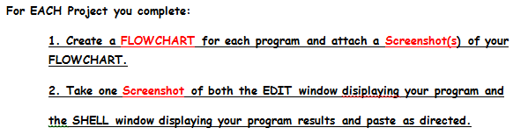

**Project 1: File Display (20 Pts)**

**Input; numbers.txt**

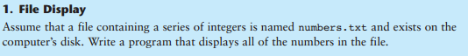

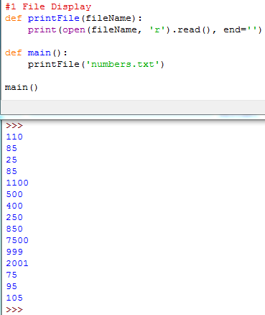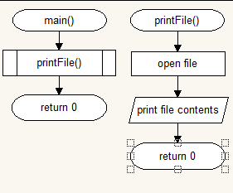

**Project 6: Average of Numbers (20 Pts)**

**Input: numbers.txt**

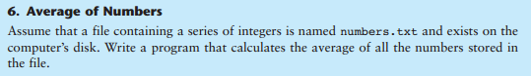

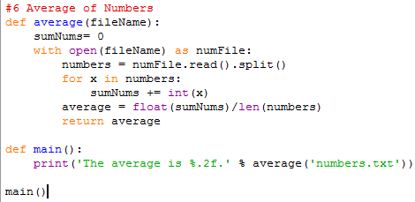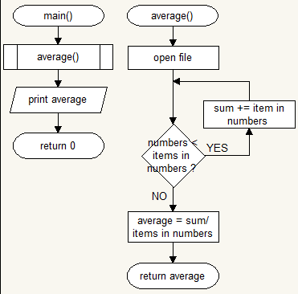

**Project 9: Exception Handling (25 Pts)**

